University of Engineering and Technology Peshawar



Task _05

Course Title: BSCS Java OOPS (lab-5)(CS-101)

Submitted To :
Syed Adeel Ali Shah Associate Professor CS&IT Peshawar
Submitted by:
Waqas khan
Registration No:24pwbcs1141

Date: 11/10 /2024

Department of CS & IT, UET Peshawar
Lab 5 Tutorial: Advanced Inheritance Concepts
Assignment Description: Simple Inventory Management Application
Objective: Create a simple inventory management application that demonstrates the concepts of inheritance, method overriding, static functions and variables, and user input using the Scanner class. The application will consist of a base class Item and derived classes for specific item types (e.g., Electronics and Groceries).
Task Breakdown:
- Classes:
  - Base Class:
    - Item
      - Attributes: itemID, itemName, and quantity.
      - Methods:
        - A constructor to initialize the item details.
        - A static variable to keep track of the total number of items in the inventory.
        - A static method to display the total count of items.
        - A method to add stock to the item.
        - A method to display item details.
  - Derived/Child Classes:
    - Electronics - Inherits from Item and includes:
      - An additional attribute for warrantyPeriod.
      - An overridden method to add stock, which could log the addition with a message about the warranty period.
    - Groceries - Inherits from Item and includes:
      - An additional attribute for expirationDate.
      - An overridden method to add stock, which checks if the item is expired before allowing stock addition.
- User Input:
  - Use the Scanner class to take input from the user for creating items in the inventory.
  - Prompt the user to enter the type of item (Electronics or Groceries), item ID, item name, and quantity.
  - After item creation, allow users to add stock to an existing item by entering the item ID and the quantity to be added.
- Method Overriding:
  - Ensure that the addStock method is overridden in both derived classes to implement specific behaviors related to each item type.
- Static Functions and Variables:
  - Implement a static function in the Item class to retrieve the total number of items in the inventory.
  - Use a static variable to maintain the count of items added, which should be incremented in the constructor of each item.
- Hints:
  - Start by designing your classes and their relationships (inheritance).
  - Think about how to structure the addStock method for each derived class to include unique functionalities.
  - Consider how user input will flow through the program—after creating an item, what actions can the user take?
  - Ensure to validate user inputs where necessary, such as checking for valid item IDs when adding stock.
Expected Outcome: By the end of this assignment, students should have a functional console application that allows users to manage an inventory of different item types while applying the concepts of inheritance, method overriding, and static methods and variables in Java.
- Welcome Message: The application starts with a welcome message and a menu of options.
- Adding Items: When the user selects the option to add an item, they choose the type of item, input the item ID, name, and quantity, and receive a confirmation message.
- Adding Stock: The user can then add stock to existing items by entering the item ID and the amount to be added, followed by a success message.
- Show Total Items: The user can view the total number of unique items in the inventory.
- Exit Option: The application ends gracefully with a goodbye message when the user chooses to exit.
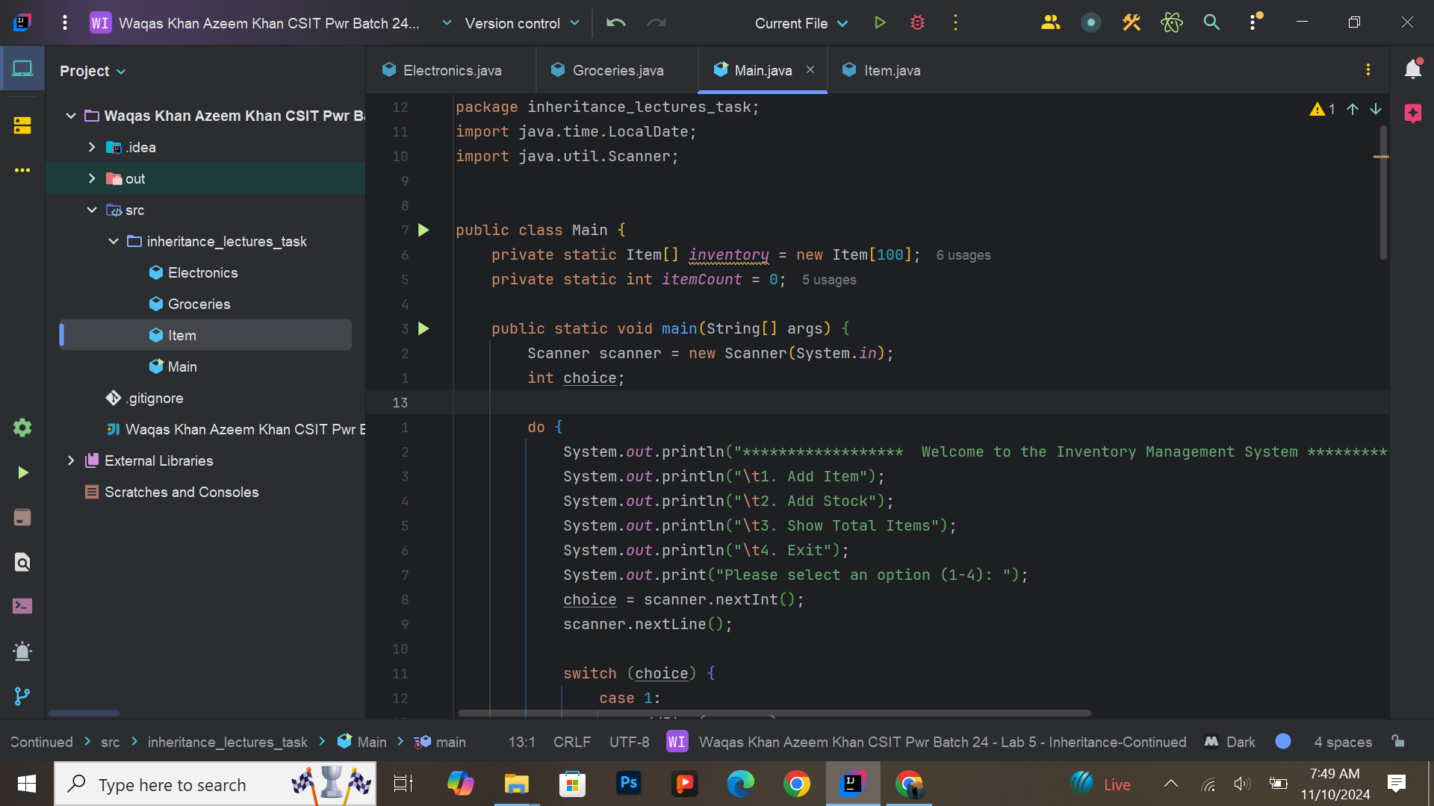
Due to lots of lines I took a screenshot of the whole document using carban.now.sh website
carban.now.sh : https://carbon.now.sh
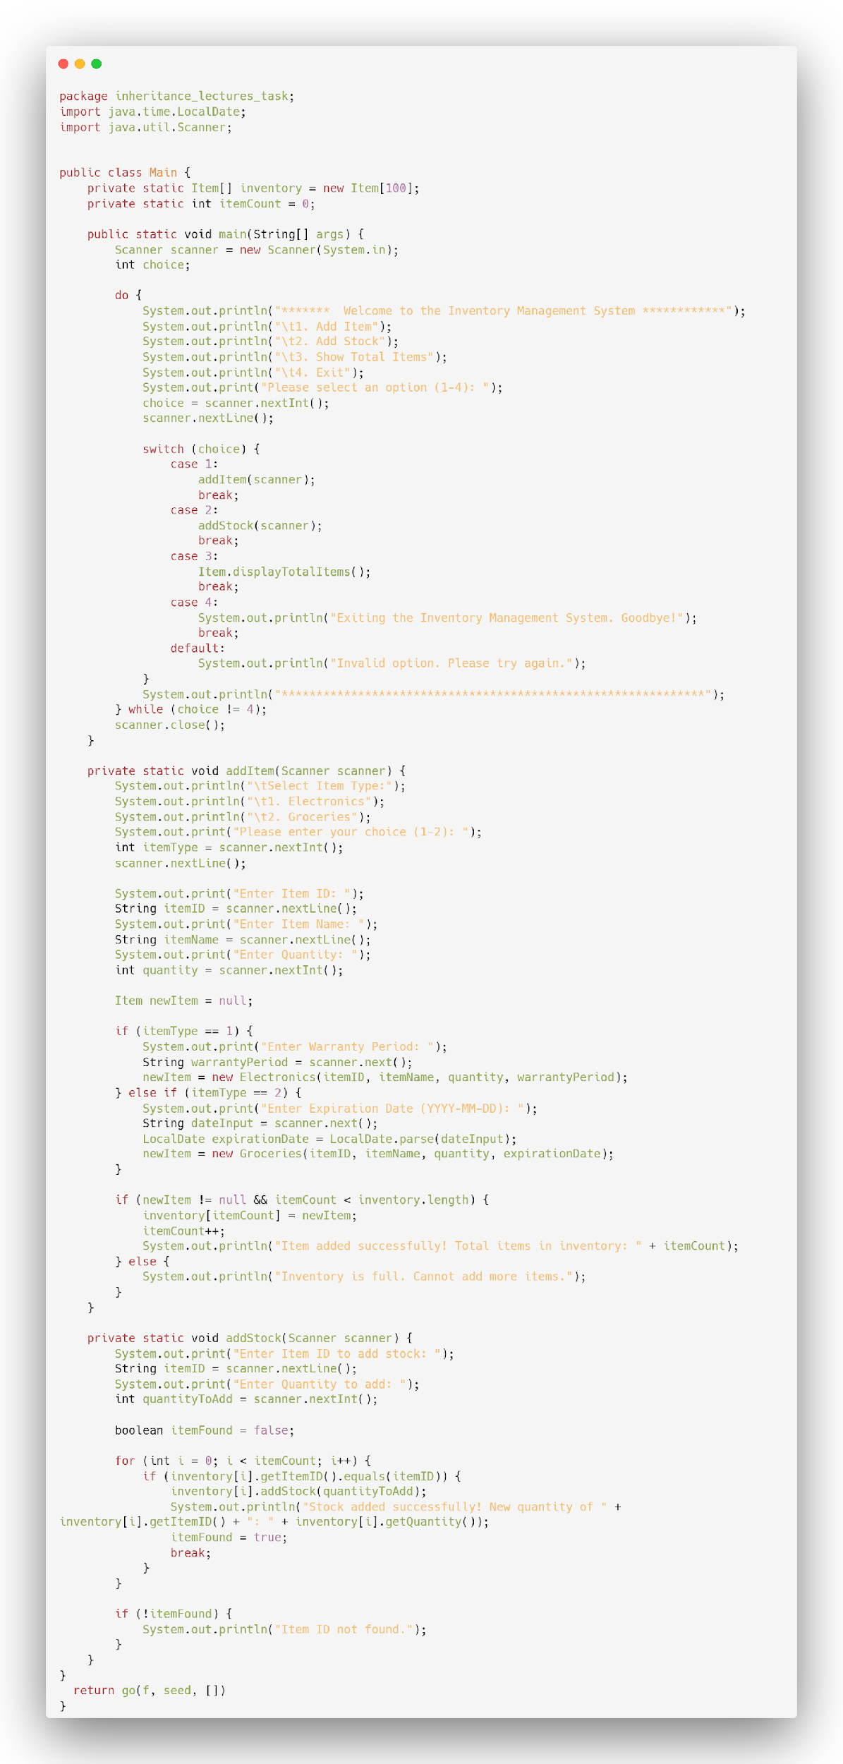

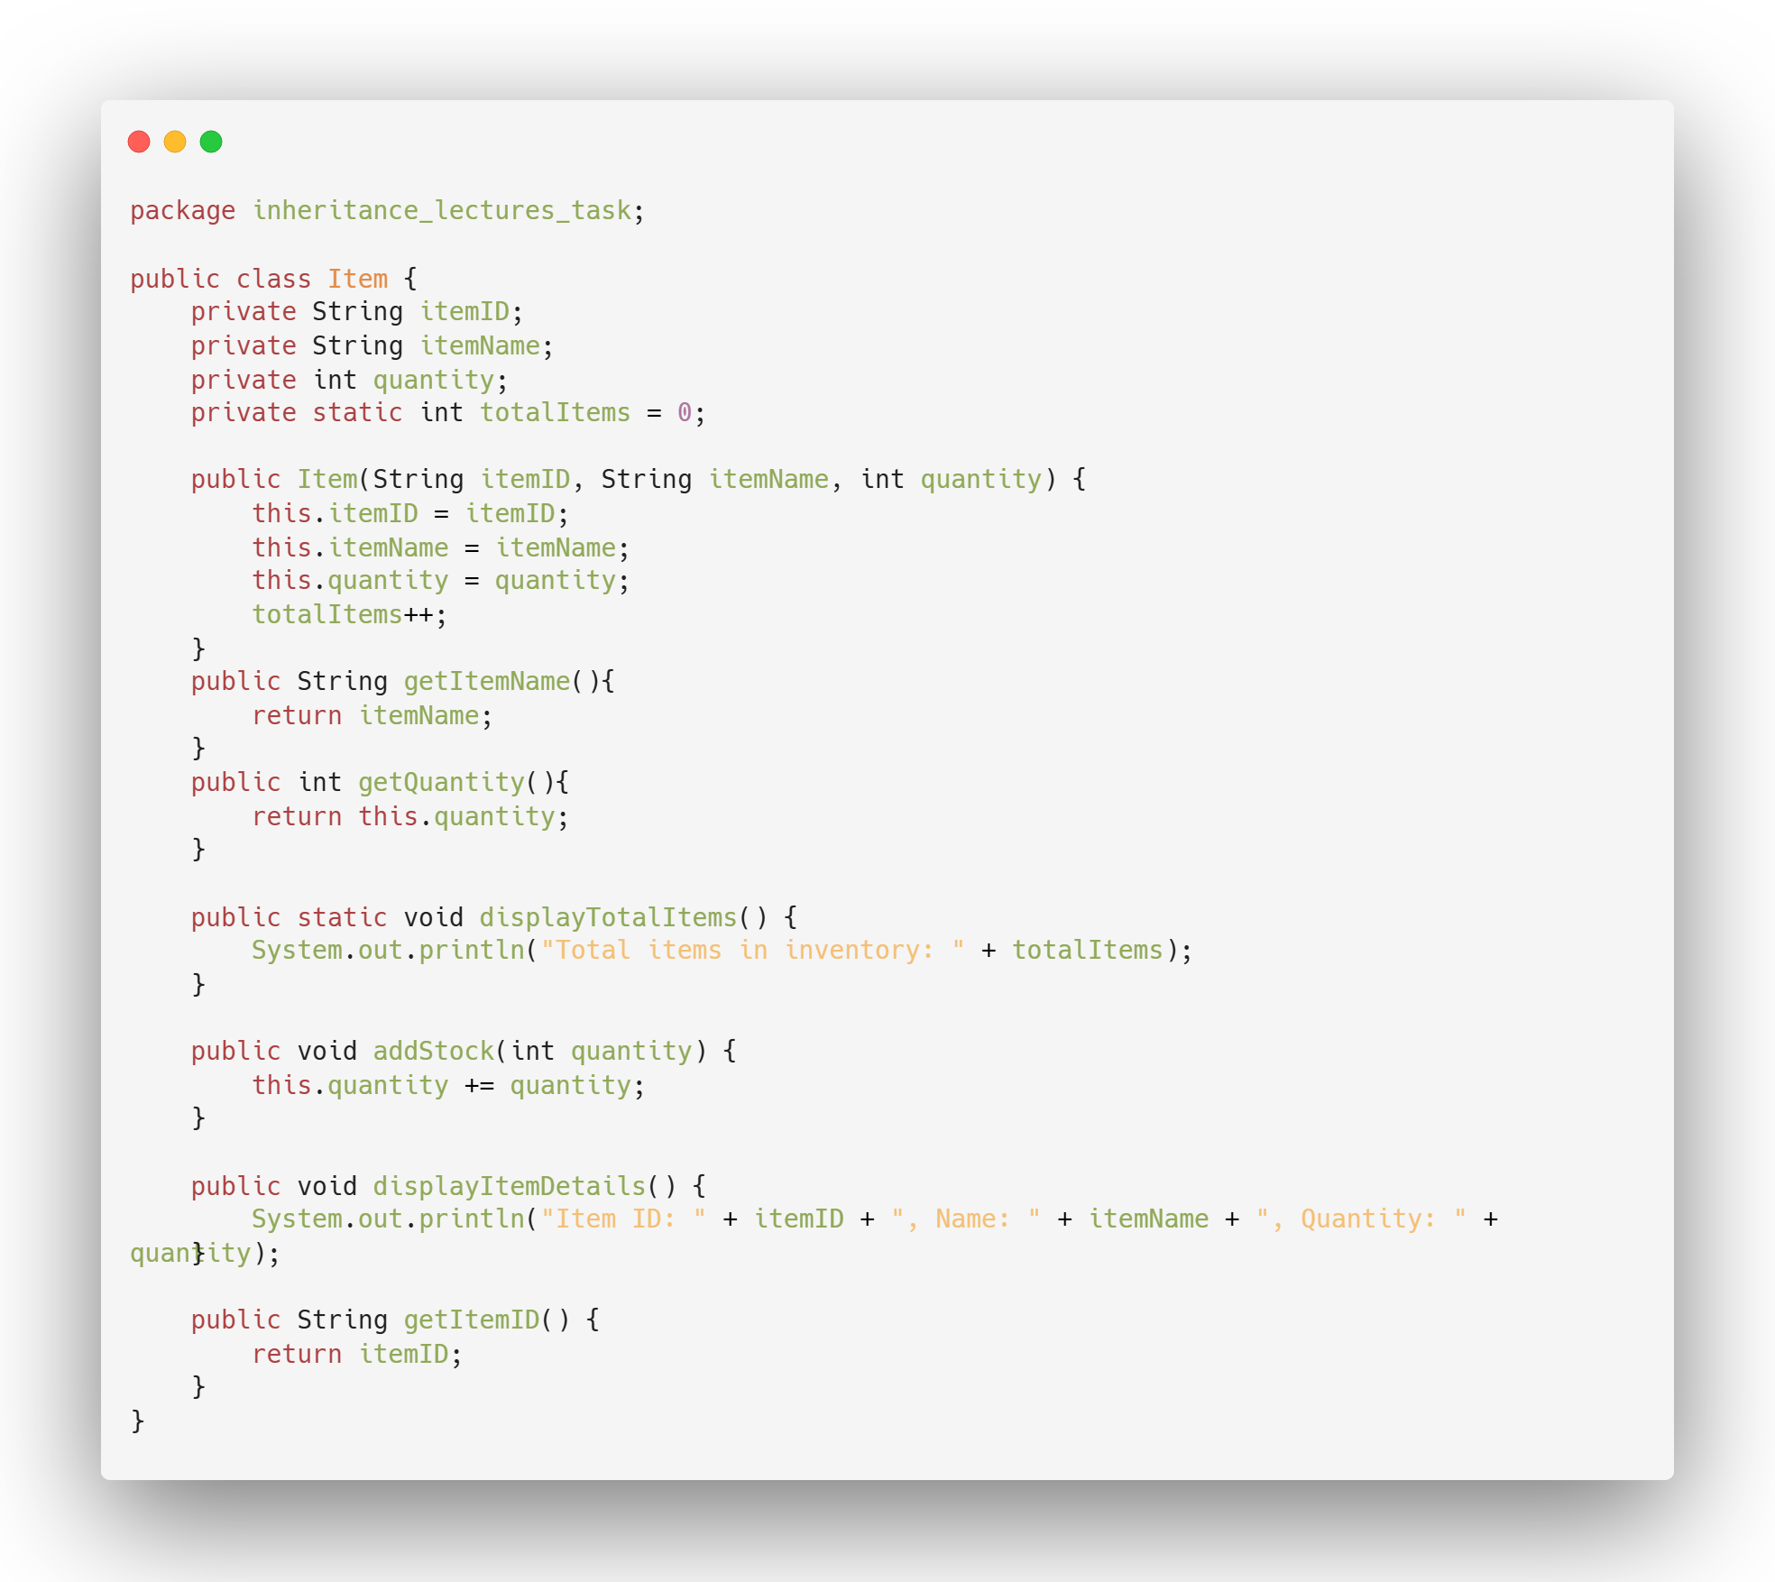

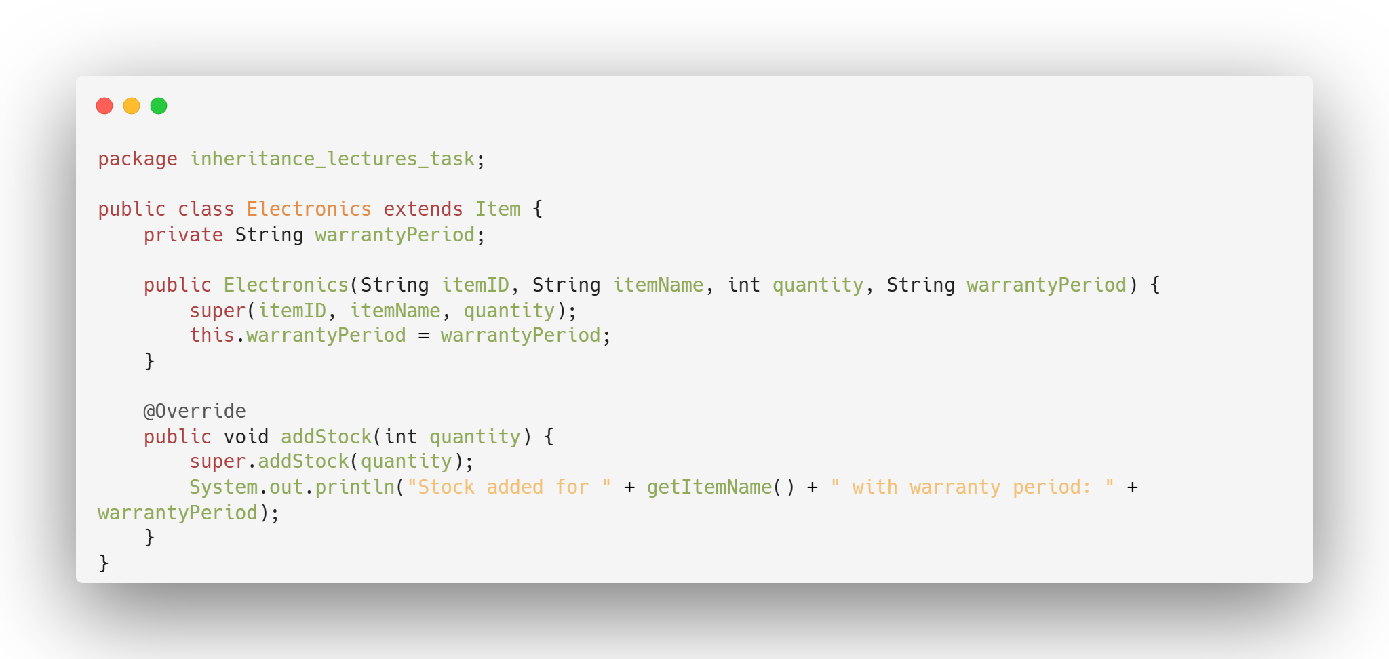
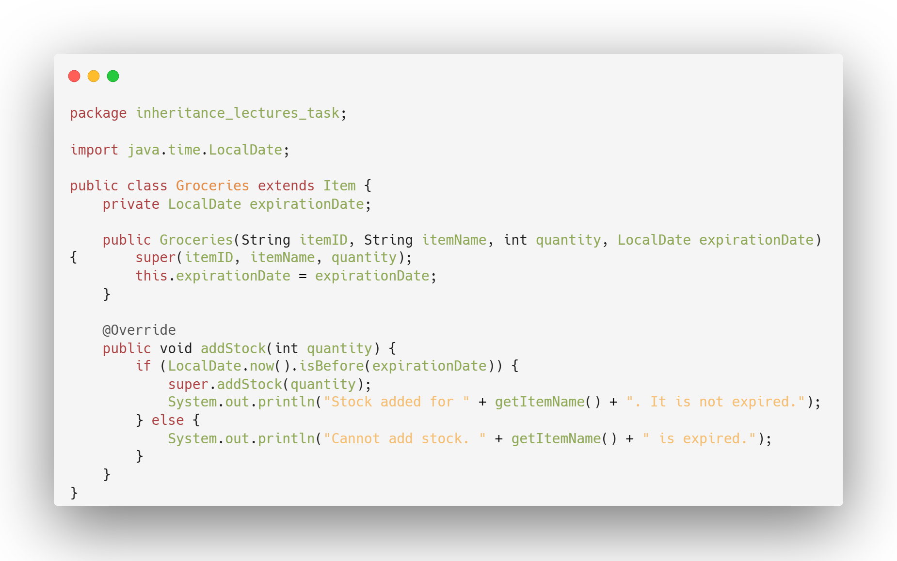

Expected Output:
